**WEB422 Project-Phase 3 Report**

|  |  |
| --- | --- |
| Group Info | Enter your Group no: 11 |
| Enter your Group name: |
| Enter your group members name: Amany, Angela, Dan |

# **Progress Made till this phase** (Outline the tasks that have be completed till now, Provide detailed information on the progress that you made so far in the project , add storyboards, output of web project)

**Amany:**1- Implemented Error Handling with Alert component in login, register pages  
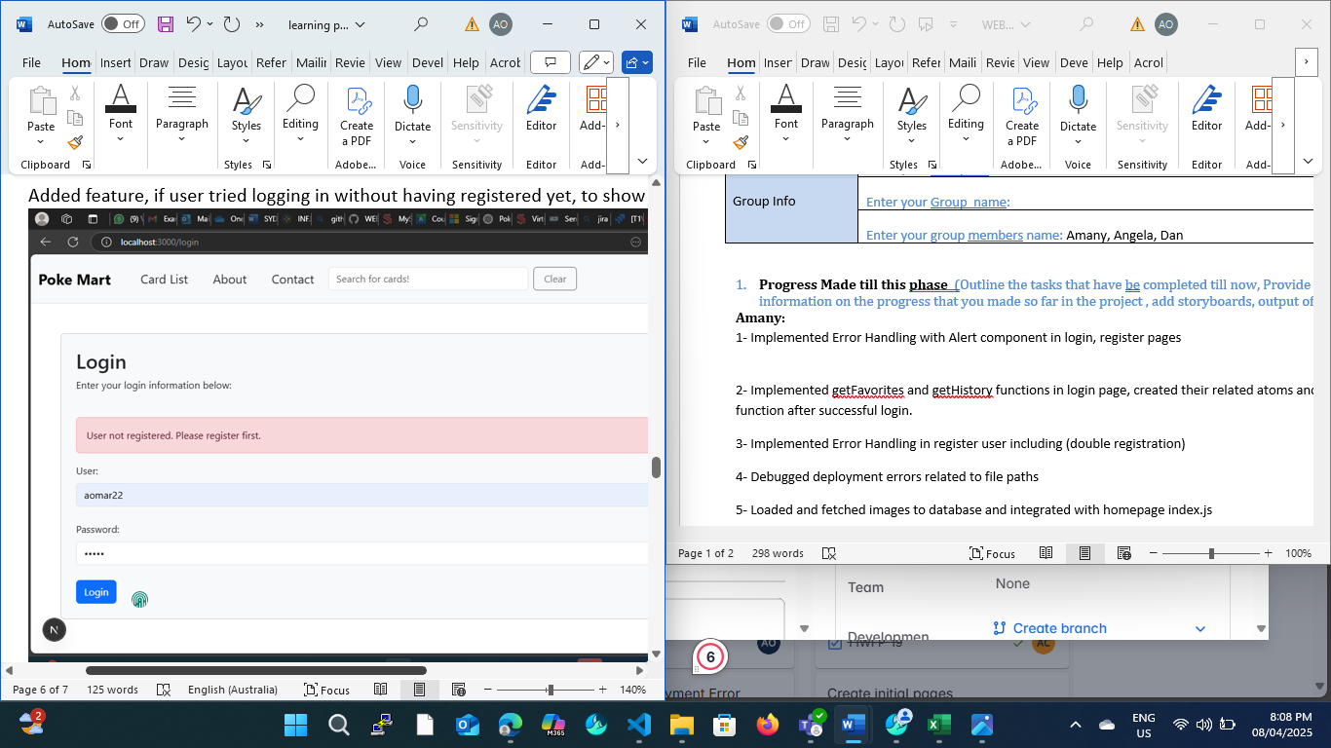

2- Implemented getFavorites and getHistory functions in login page, created their related atoms and updateAtom function after successful login.  
3- Implemented Error Handling in register user including (double registration, password mismatch)  
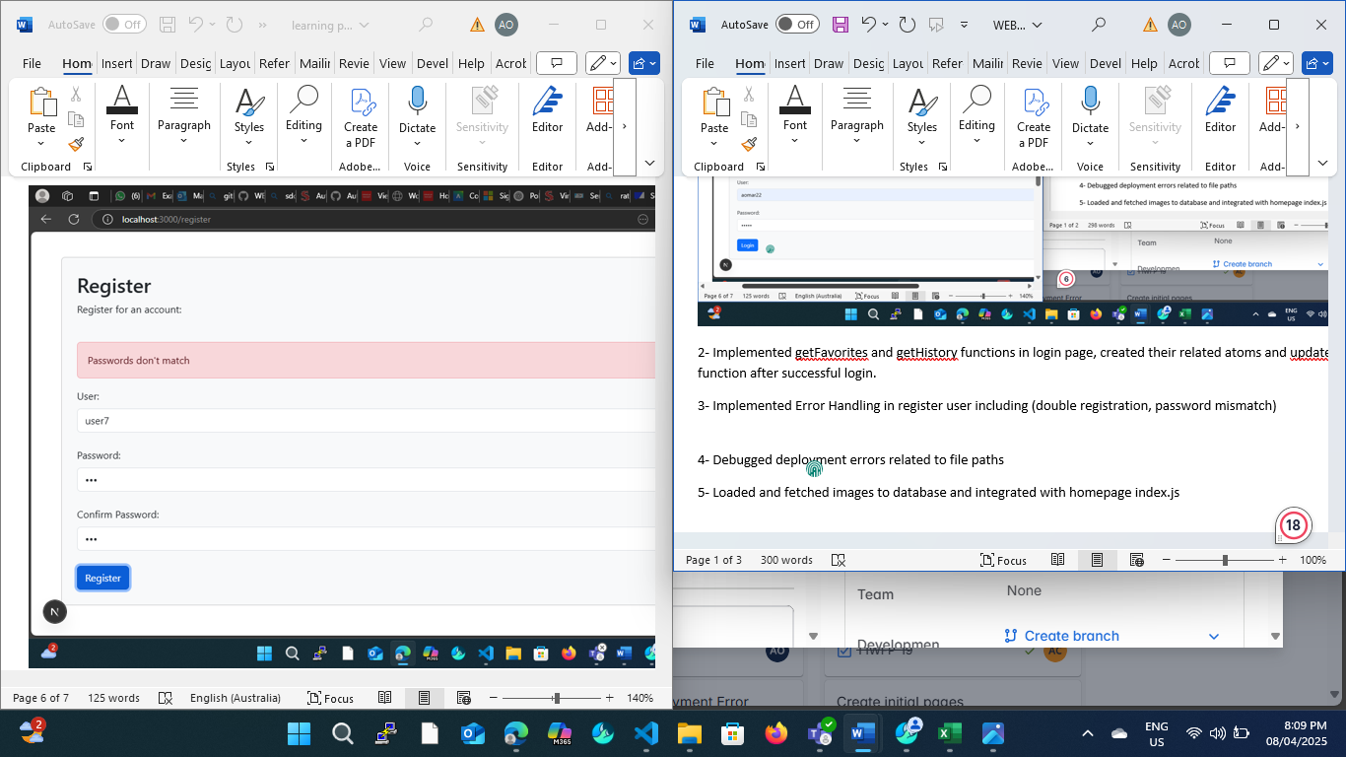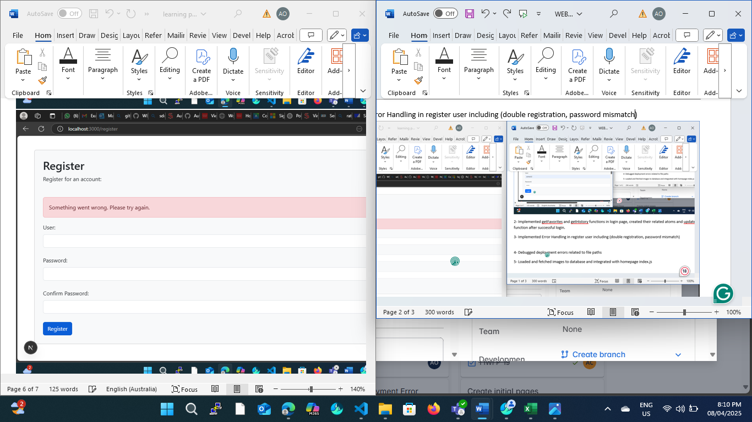

4- Debugged deployment errors

5- Loaded and fetched images to database and integrated with homepage index.js + favorite icon

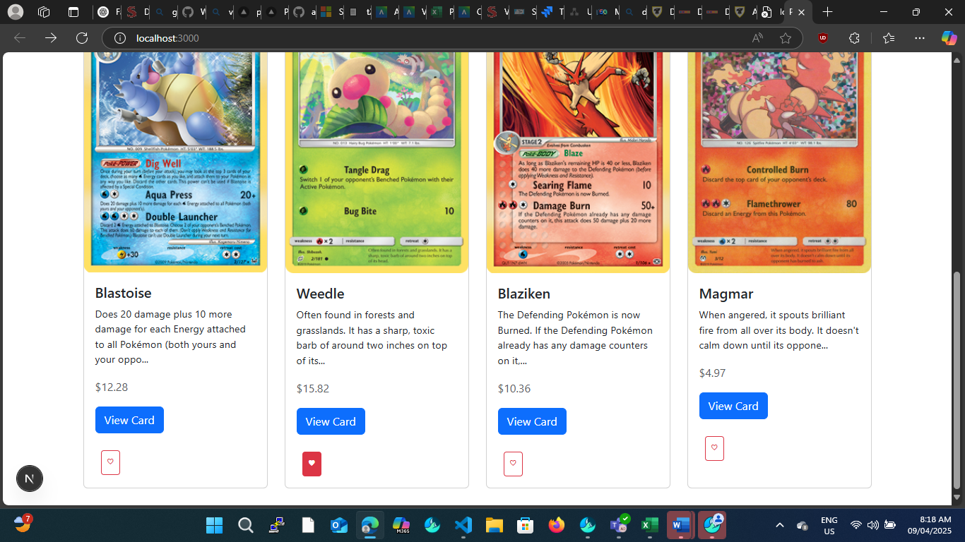

6- Implemented authenticate.js file

Angela:

* Implemented favorites page + interacting with the API through a protected route
* 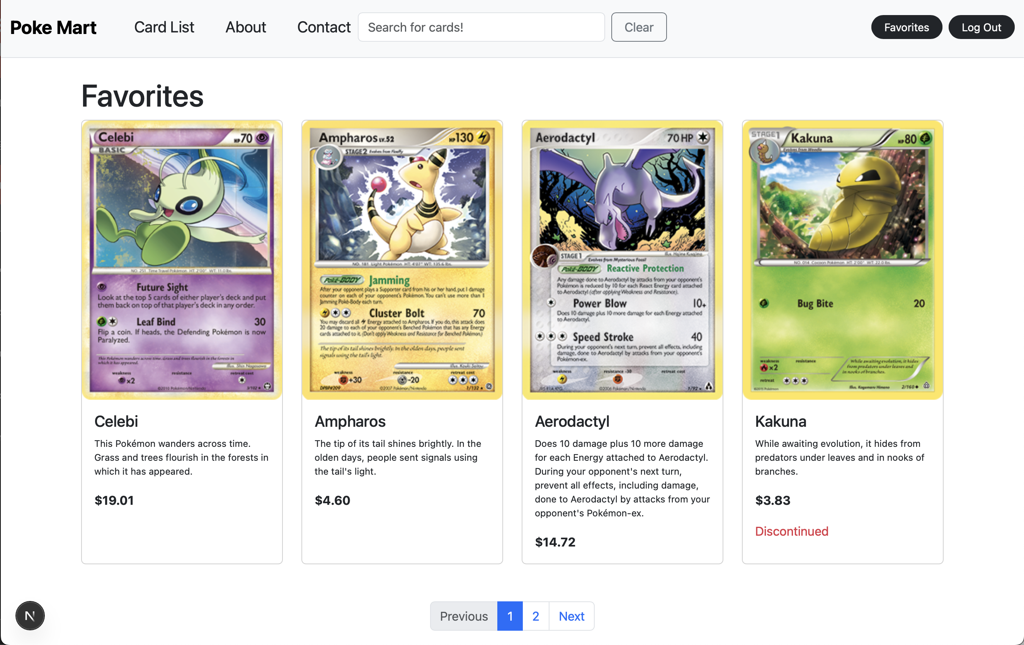
* Provided a dynamic navbar that changes depending on if the user is logged in
* 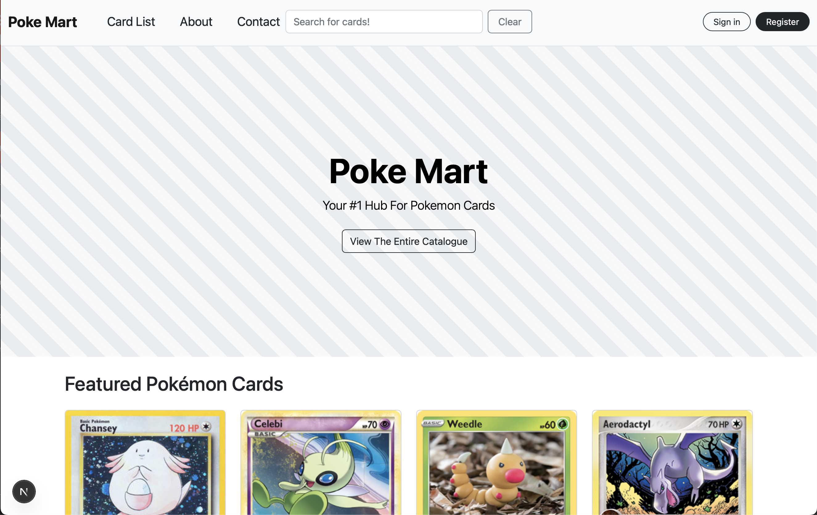
* Added adding/removing cards from favorites via the specific card page
* 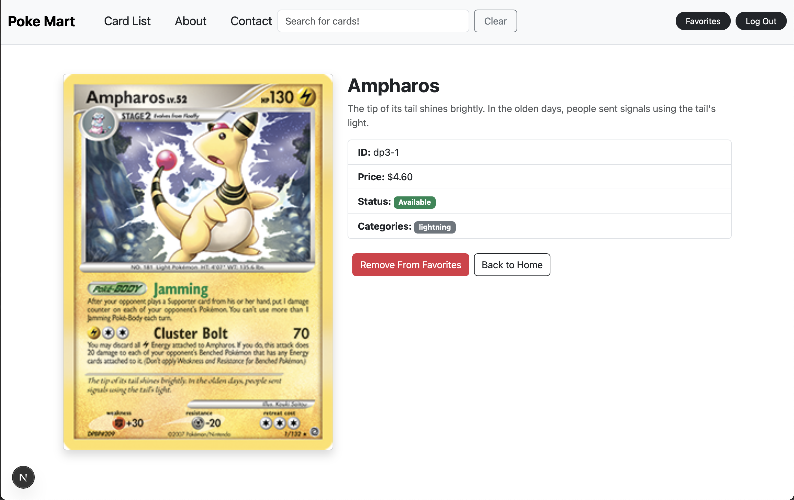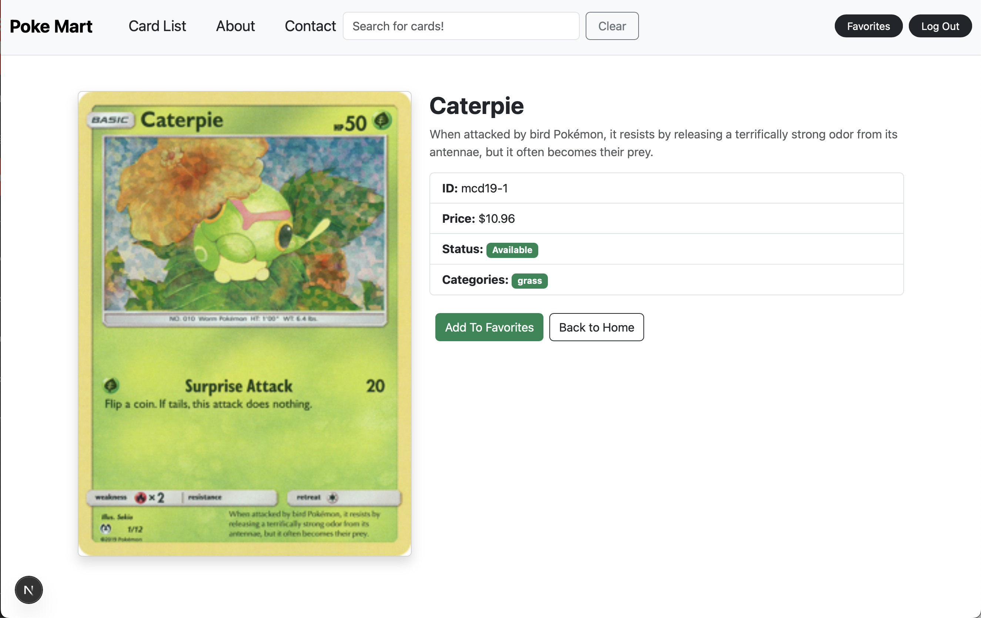
* Tested JWT protected routes in appropriate pages (put/delete favorites, put/delete history, etc)

# **Complete the following Checklist:**

|  |  |
| --- | --- |
|  | Answer |
| store’s name, slogan/description, product/service type, and inventory details | Completed in phase 1 |
| API testing, integration, utilization | Completed in phase 2 |
| Visualizing data in Card design, Css library | Completed in phase 1 |
| Pagination | Completed in phase 2 |
| User Management API Setup, MongoDB | Complete in phase 2 |
| Have you designed any ERD for storing User/Favorite data? | No |
| Login, Register, JWT, protected route | Login register page finalized by Angela, Dan and Amany. JWT protected routes via user API done by Angela via jwt.verify. |
| Favorite product/ wishlist | Angela completed favorites page and adding/removing an item via the card [id] page. Adding favorities via the home and product page is started by Amany and will be finalized for the next phase. |
| State management | Used state management in login and register pages to capture user’s name and passwords |
| Deployment and Hosting | Debugged Vercel Deployment errors |
| Additional Functionalities |  |
| Link to deployed frontEnd/backEnd | [Poké Mart](https://pokemon-trade-six.vercel.app/) |

# **How did you divide the work?** (Provide detailed information on the task-assigning to each member)

Amany – see question 1

Angela – added favorites functionality, added JWT protection and tested it

# **Difficulties Encountered during this phase** (Provide detailed information on the difficulties and challenges that you encountered in the project so far)

Angela: I felt that the current way the user API is pretty flawed since each api call is executed to only be called once each, and not at the same time. This made it where when I wanted to make multiple calls at the same time, the latest one would fail since the other call had already disconnected from the database. For the next phase, I plan on improving the user api so this doesn’t happen.

# **Tasks to Be Completed in Next phases** (Outline the tasks to be completed in the following week and how do you divide the work)

* Search history
* Finalizing index and product pages
* Improving and finalizing the user API (Angela)
* Improving and finalizing the UI
* Bug fixes (All)

# Research question: “Postman Collections” are the gold standard for API organization in big projects. Take a look at its advantage and share your feedback on the advantage of utilizing this in your project planning.

[**https://www.postman.com/collection/**](https://www.postman.com/collection/)

From the main site, it seems that Postman acts as an API manager, where one can easily manage APIs and store it through Postman. One thing that I can see is the use of storing common requests, which can be useful for speeding up the process of creating a collection. Other features also include integration testing with you API to make sure that it’s working. Looking at what it can do, it seems like this can be greatly useful in managing the APIs that we use and created already.

# **How do you evaluate your progress** (Evaluate your team progress in this phase and mark your team out of 10)

Maybe 7/10, we got a lot of stuff done but there’s still some things we need to take care of for the last phase.